|  |  |  |  |
| --- | --- | --- | --- |
| TEST CASE 1 - Input | Expected Output | Actual Output | Pass or Fail |
| Weights1.txt  (tab in file separating)  lbs oz  12 17  14 17  16 16  26 82  15 30  12 500  32 30  15 23  18 18  12 19  140 180  13 18  47 18  89 20  89 18  54 45  79 30  140 180  48 18  12 18  30 170  35 17  120 18  18 82  13 20 | No Exceptions.  Minimum Weight: 13.0lbs 1.000oz  Maximum Weight: 151lbs 4oz  Average Weight:  47.0lbs 15.520oz | No Exceptions  Minimum weight: 13.0lbs 1.000oz  Maximum weight: 151.0lbs 4.000oz  Average weight: 47.0lbs 15.520oz | Pass |

Test case 1 ensures that program runs with 25 weights in file, and that it can handle large oz values.

**SCREENSHOTS TEST CASE 1:**

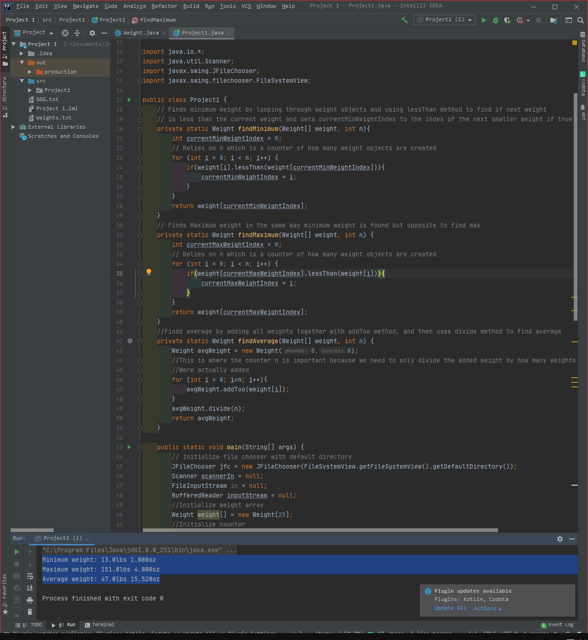

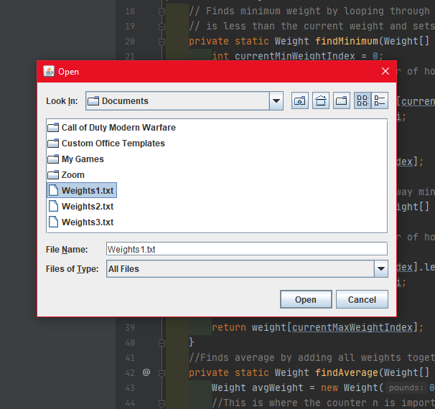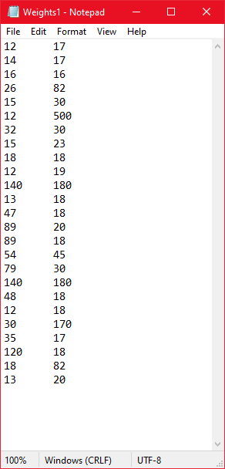

|  |  |  |  |
| --- | --- | --- | --- |
| TEST CASE 2 - Input | Expected Output | Actual Output | Pass or Fail |
| Weights2.txt  (tab in file separating)  lbs oz  14 15  14 13  16 11  26 20  15 30  8 10  32 30  15 23  18 18  9 12  19 15  10 15  47 10  89 100 | No Exceptions.  Minimum Weight: 8.0lbs 10.000oz  Maximum Weight: 95lbs 4oz  Average Weight:  25.0lbs 2.429oz | No Exceptions  Minimum weight: 8.0lbs 10.000oz  Maximum weight: 95.0lbs 4.000oz  Average weight: 25.0lbs 2.429oz | Pass |

Test Case 2 ensures that program works with file containing less than 25 weights, most importantly that average comes out correctly, because it is where I think an issue could arise if program always creates 25 weight objects, but then again if this were the case the average would probably be wrong too.

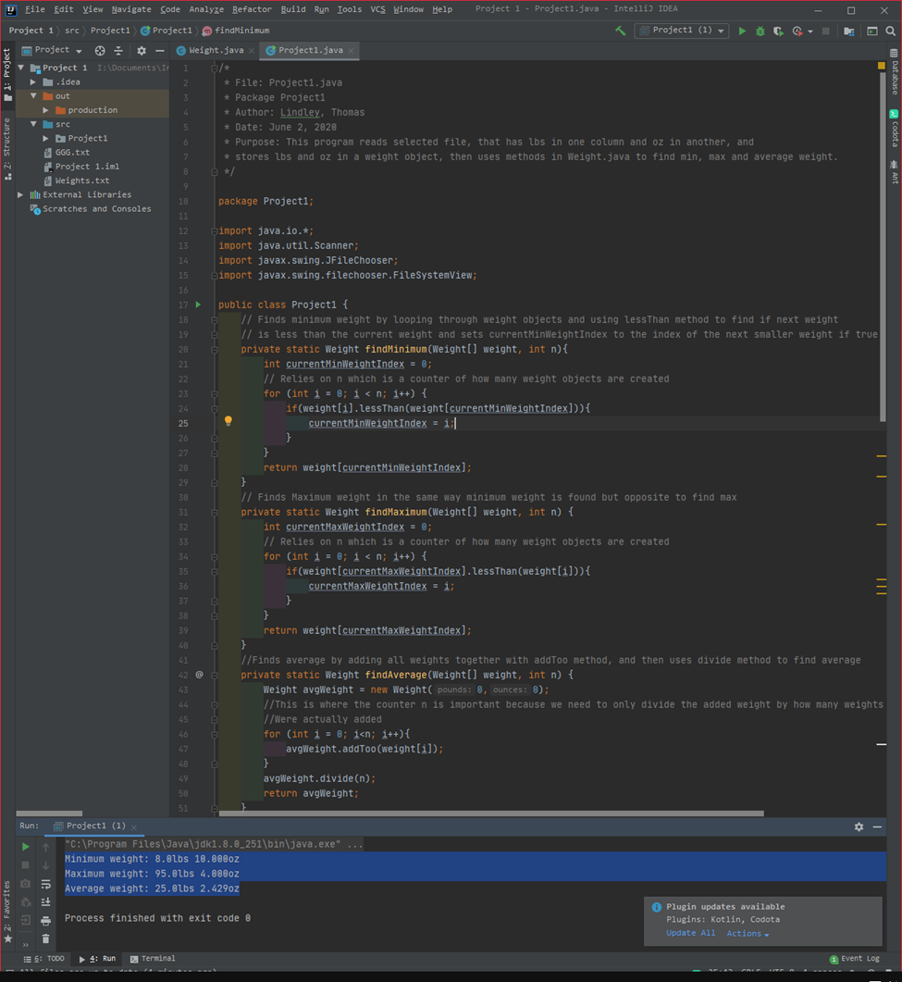**TEST CASE 2 SCREENSHOTS:**

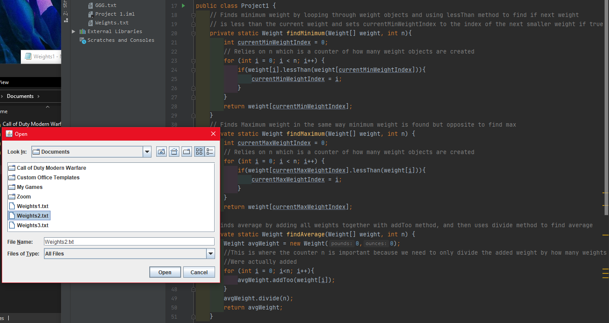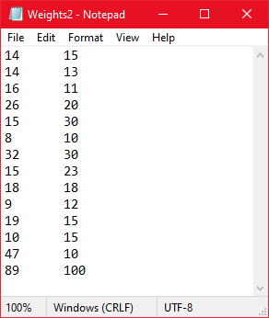

|  |  |  |  |
| --- | --- | --- | --- |
| TEST CASE 3 - Input | Expected Output | Actual Output | Pass or Fail |
| Weights3.txt  (tab in file separating)  15 17  16 17  18 16  26 82  15 30  12 50  32 30  15 23  18 18  12 19  14 18  18 18  47 18  89 20  89 18  54 45  79 30  14 18  48 18  12 18  30 17  35 17  12 18  18 82  13 20  35 17  12 18  18 82  13 20 | Array index out of bounds exception. | Array index out of bounds exception: 25 | Pass |

Test case 3 is to test if program handles exception and exits if file contains too many weights

**TEST CASE 3 SCREENSHOTS:** 